**1000 Books before Kindergarten**

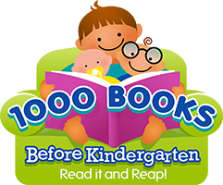

**At the Brown County Public Library!**

**Welcome parents and caregivers,**

1000 Books before Kindergarten is a national incentive designed to promote reading aloud in order to help kids get ready to read on their own! 1000 books may sound like a lot, but once you start, you will see just how easy it is to do. If you read just one book a day you will have read 365 books in a year!

**\*The program is simple- Read books (any books) with your child!** Fill in a feather on your log sheet for each book read. Reading the same books multiple times counts, and is a great way for kids to take ownership over their reading habits. After one hundred books, come back to the library for your next sheet and a sticker! Feel free to write in the titles of favorite books along the way on the back of the log sheet.

**\*Incentives**- Along the way, your child will get small prizes and big prizes to keep them going. The starting incentive is a bag and this handy folder! At 500 books your child will receive a book of their very own, and upon completion of the program your child will receive a t-shirt!

**\*Who can participate?** Any child from birth until the age they enter kindergarten.

**\*How long will this take?** The program can take anywhere from a few months to a few years! It’s really up to you and your child.

**How many children can participate?** All of them! This program is designed for participation from the whole family. Sharing books together is the goal!

**\*How much does it cost?** It’s Free! Anyone can get a library card and have access to thousands of books and materials absolutely free!

**\*Is there more information somewhere?** Yes! Please check out our website for more information about this and all of our other exciting programs! browncountylibrary.info

**Happy Reading!**